Chapter 7, Solution 51.

Consider the circuit below.

L
R
i

+
−
+
v
−
V_{S}
t = 0
After the switch is closed, applying KVL gives
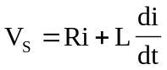
or 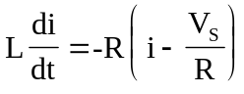
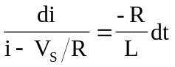

Integrating both sides,
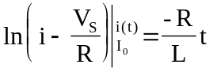
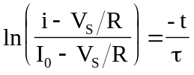
or 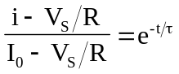
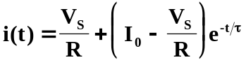
which is the same as Eq. (7.60).

